Employee Records - Updating Payroll-Related Documents on PeopleAdmin
Please follow instructions on the first 4 pages to access PeopleAdmin. Click on the form you wish to add/update. Refer to the forms and pages below for specific instructions.

The following payroll-related forms are now updated on PeopleAdmin:
(no paper forms will be accepted by the Payroll Office)

- 457(b) Salary Reduction Agreement (pg. 5)
- Direct Deposit Authorization Form – Banking (pg. 6)
- NY 529 College Savings – Direct Deposit Form (pg. 7)
- NYS IT – 2104 Form AND NYS IT – 2104 Exempt (pg. 8)
- W-4 (pg. 9)

If OFF Campus: Go to the SUNY NIAGARA homepage (http://sunyniagara.edu/) Click “MYSUNY NIAGARA” and PeopleAdmin. (note: you can access the college’s website anywhere)
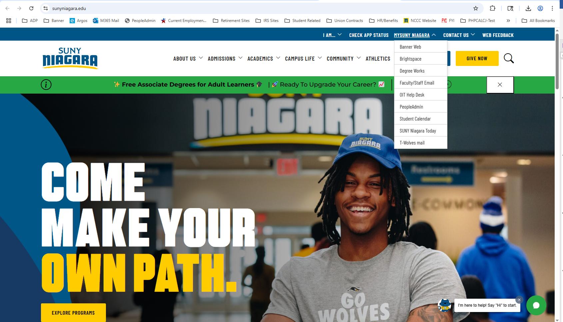

If ON Campus: Go to the FYI page and click on PeopleAdmin link:
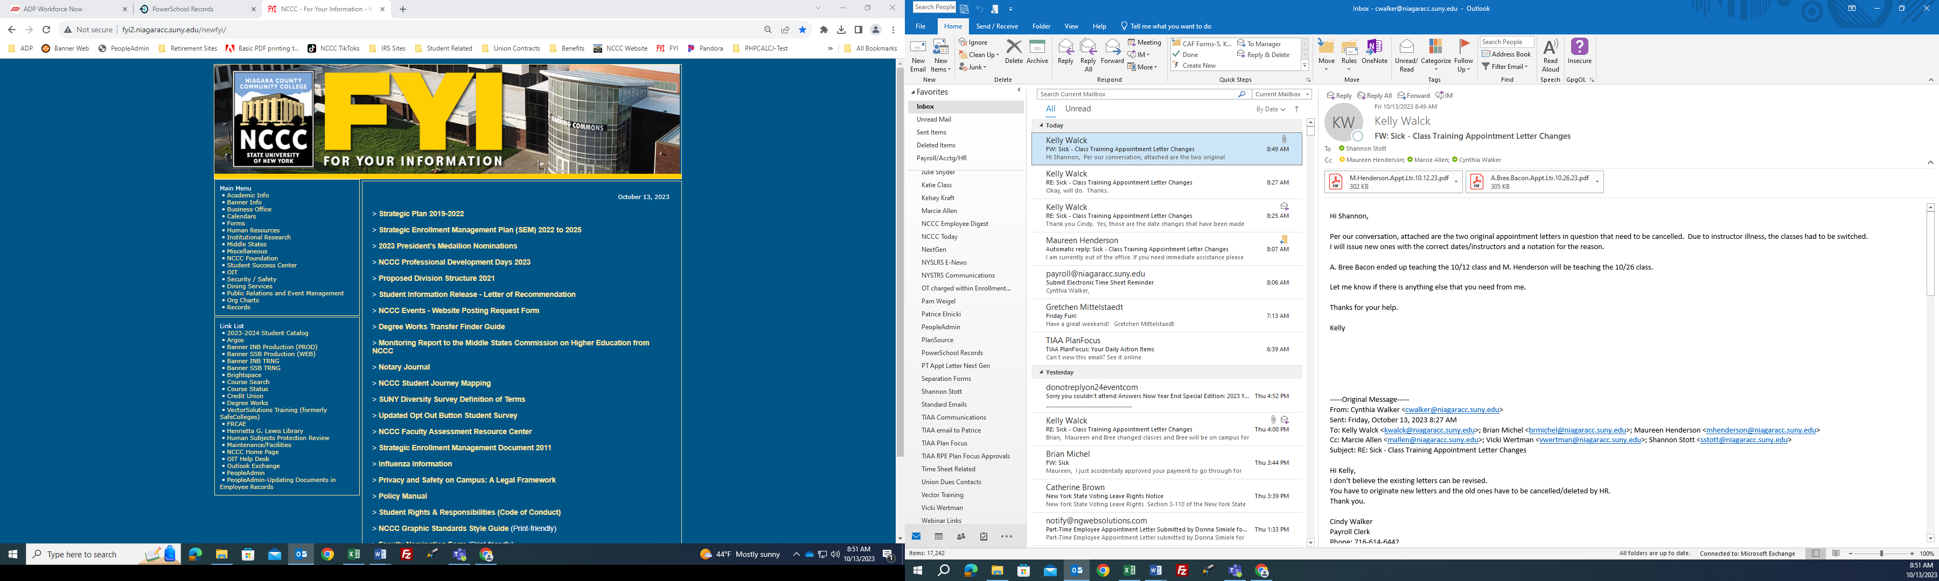

Use the SSO (single-sign on) to log into PeopleAdmin.
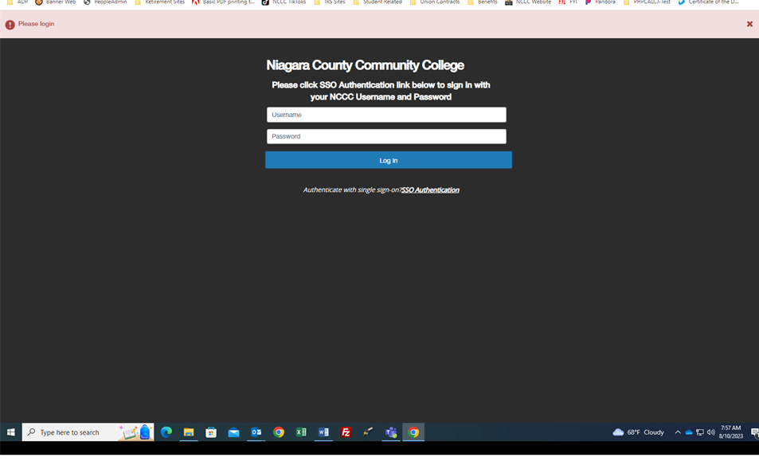

Click on the three horizontal dots to the left of “Employee Records” or “Applicant Tracking System”, then click Employee Records.
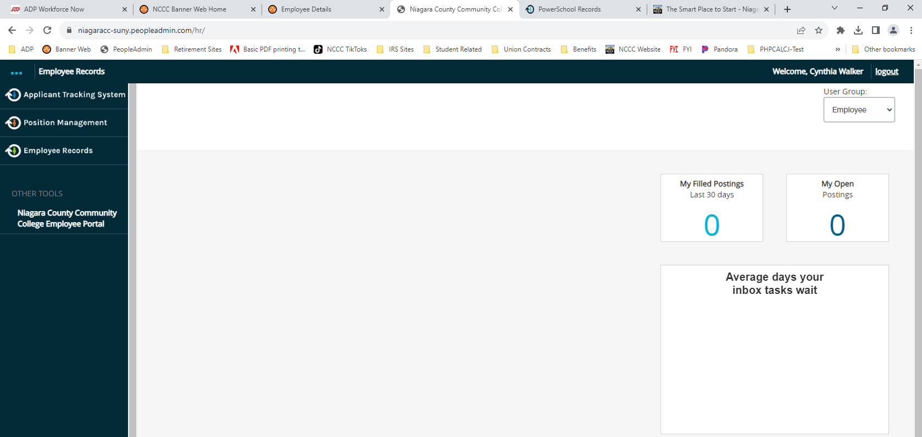

Steps 1 through 4 will be consistent with all payroll-related form updates.
Step 1: Click on the Available Forms Icon in the Task Bar, located on the left-hand side of the Records Module.
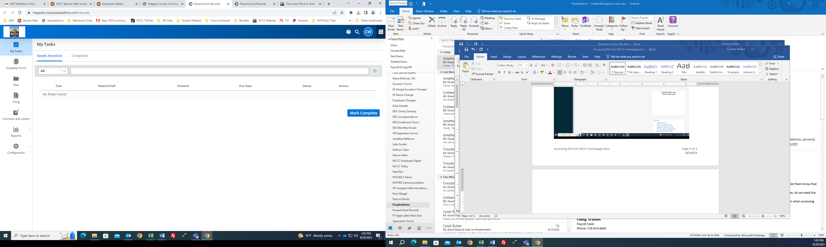

Step 2: Click on the payroll-related document that you would like to update or upload.
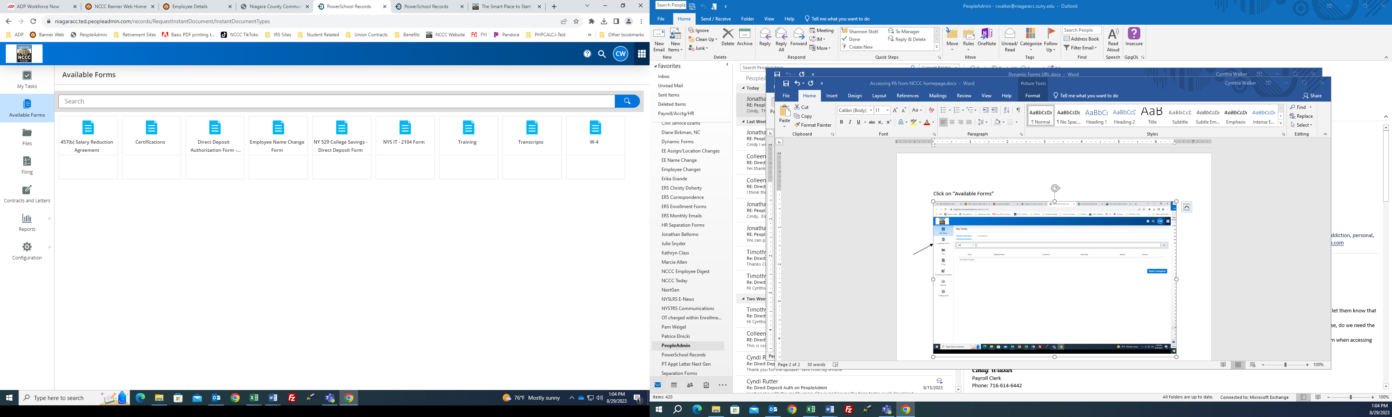
(5)
(4)
(3)
(2)
(1)

Step 3: When asked “How would you like to add this document?” Click the radio button “Add for myself”
Step 4: Click on Add as an E-Form. (in the event you are uploading a document, you would have that as an option)
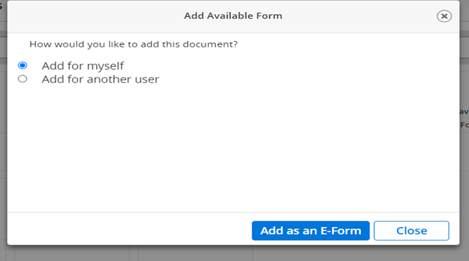

- 457(b) Salary Reduction Agreement – BEFORE COMPLETING THIS SALARY REDUCTION AGREEMENT, you must create an account with NYS Deferred Compensation Plan. Please visit this site to find/contact our local account representative for Niagara County:

https://www.nysdcp.com/rsc-web-preauth/contact/meet-your-account-executives
If you have any question, please contact the Human Resources Office at (716) 614-5952.

When adding or updating this form, click on the form, Add for Myself, and click Add as an E-Form. After filling in your personal information and adding the salary reduction effective date, choose your reduction election. Click Save Final. You will then receive an email from PowerSchool Records with a notification that there is a document that requires your signature. Click on the direct link to complete the E-Form.
PowerSchool Records - Signature Required - Niagara County Community College
Hello Cynthia,

You have a document in Records that requires your signature. If you wish to view the document directly, please click here.

Document Name: 457(b) Salary Reduction Agreement
Related Staff: Cynthia Walker
Related Staff Location: Business Office

If you wish to view all of your tasks, please click the link below.
Log In

Add your name on the signature line, check the box accepting consent to eSign, and click submit.
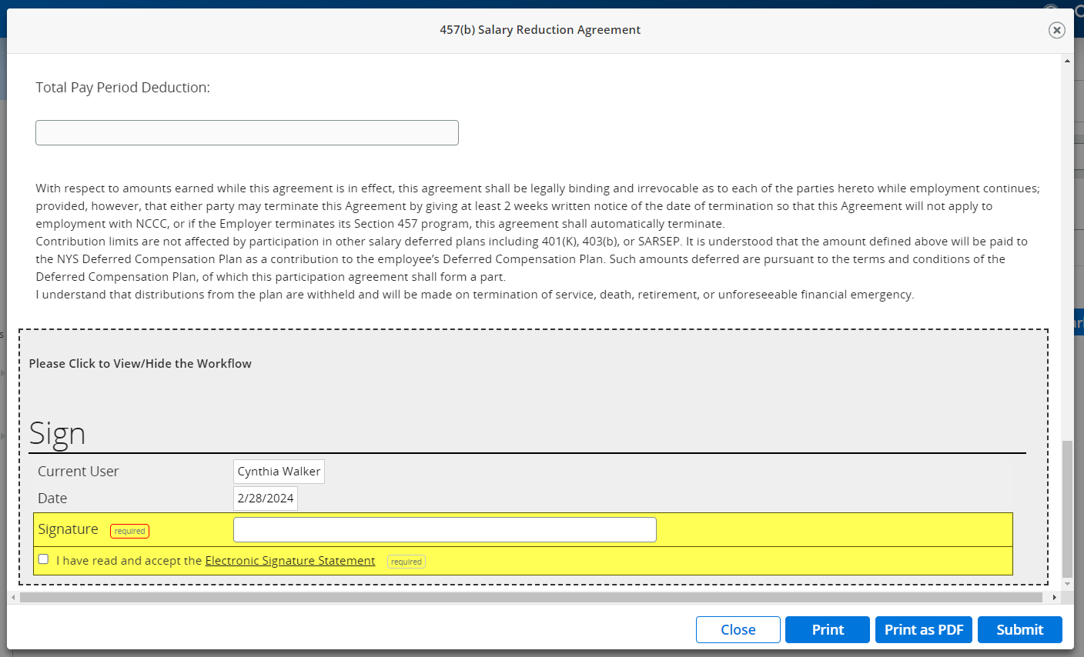
- Direct Deposit Authorization Form – When adding or updating this form, click on the form, Add for Myself, and click Add as an E-Form.
  - Complete your full name and today’s date. In Section #1, choose whether you wish to add a new account or change an existing account.
  - The Primary Deposit Account is the account you want your “net” pay amount to be deposited.
  - Type in the name of the Primary Institution.
  - The institution’s Routing Number (this will be 9 digits)
  - Type in the deposit account number.
  - If you would like a “flat” amount deposited into a Secondary Deposit Account, please note the type of account, and the flat amount you wish to be deposited.
  - Type the name of the Secondary Institution.
  - The institution’s Routing Number (this will be 9 digits)
  - Type in the deposit account number.
  - You may add a Third Deposit Account, with a “flat” amount to deposit as well.
  - If this is a “change” and you currently have a deposit account that will no longer be active, please complete Section #2, Cancellation, and note account numbers being cancelled.
  - Attachments – Please attach the banking detail to support EACH deposit account. This attachment can be a voided check, a document from your banking institution(s), or a screenshot from a banking app. You can take a screenshot and save the file, then attach to your E-Form.
  - Click Save Final to move onto the signature step, sign the E-Form. Click the box to the left of “I have read….” And accept the Electronic Signature Statement” Click Submit.
After the Payroll Office receives your Direct Deposit Authorization form through PeopleAdmin, your direct deposit will be set up. You will then receive an email from ADP stating that your direct deposit information was updated. Based on your banking institution, your direct deposit may take a payroll cycle due to a verification process.
NYS 529 College Savings Direct Deposit Form – When adding or updating this form, click on the form, Add for Myself, and click Add as an E-Form.
- Complete all demographic information.
- Choose new enrollment, change, or cancellation.
- The Institution and Bank Routing Number are pre-populated.
- Add your specific Account Number.
- Attachments – Please attach the Payroll Authorization Form that you printed at the end of the enrollment process on WWW.NY529atwork.org
- Click Save Final to move onto the signature step, sign the E-Form. Click the box to the left of “I have read….” And accept the Electronic Signature Statement” Click Submit.

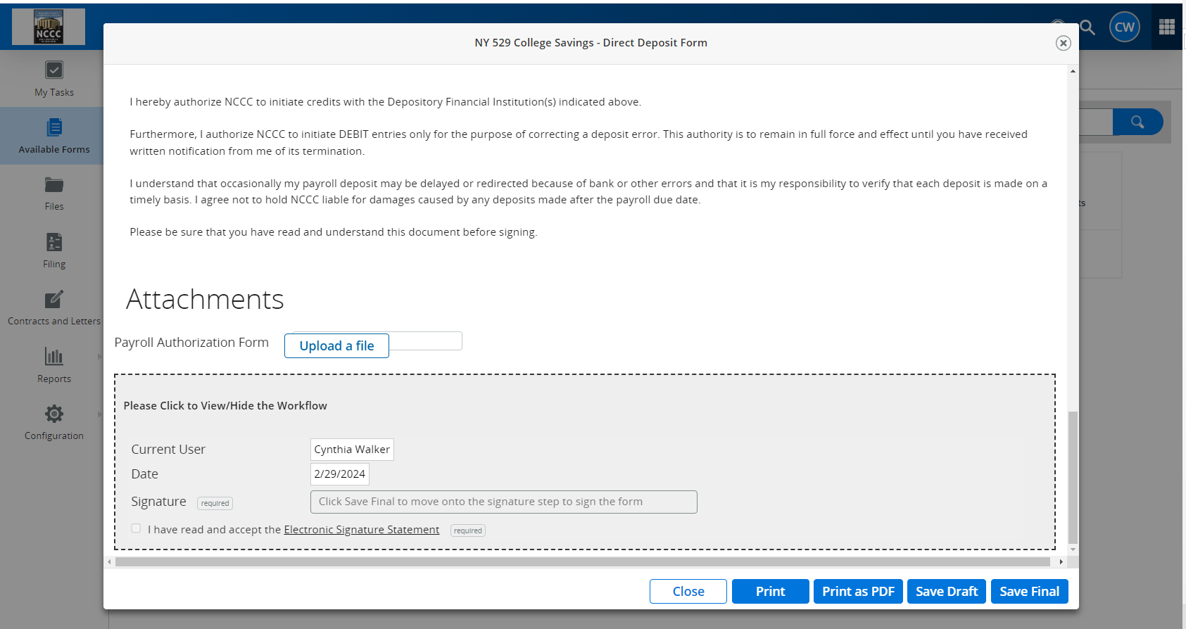
Attach/upload your Payroll Authorization Form

- NYS IT – 2104 Form AND NYS IT – 2104 EXEMPT - When adding or updating this form, click on the form, Add for Myself, and click Add as an E-Form. This form is a fillable PDF, as you will see in the next instruction.
- Next, you will see this dialog box, which will direct you to download the fillable version of the IT-2104 form. There are also instructions for completing the form, which you can reference.
- Once you complete the form electronically, save the form on your desktop. You will not be able to sign the E-Form after you complete it. After you have saved the form to your desktop, upload it back into the form using the upload a file button.
- Click the Save Final button at the lower right of dialog box.
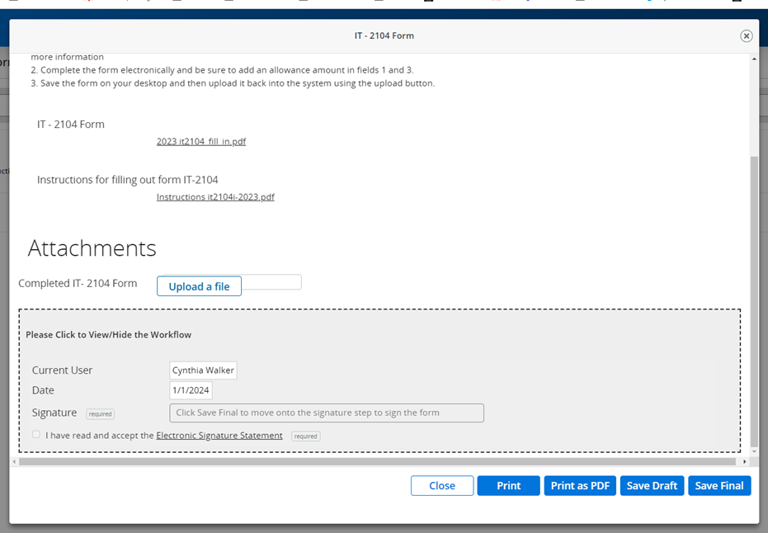
Attach your completed
IT-2104 form
Blank
IT-2104 fillable form
After you attach your IT-2104 form and click Save Final, you will be asked to type your signature in the Signature box. Click the box to the left of “I have read and accept the Electronic Signature Statement” and Submit.
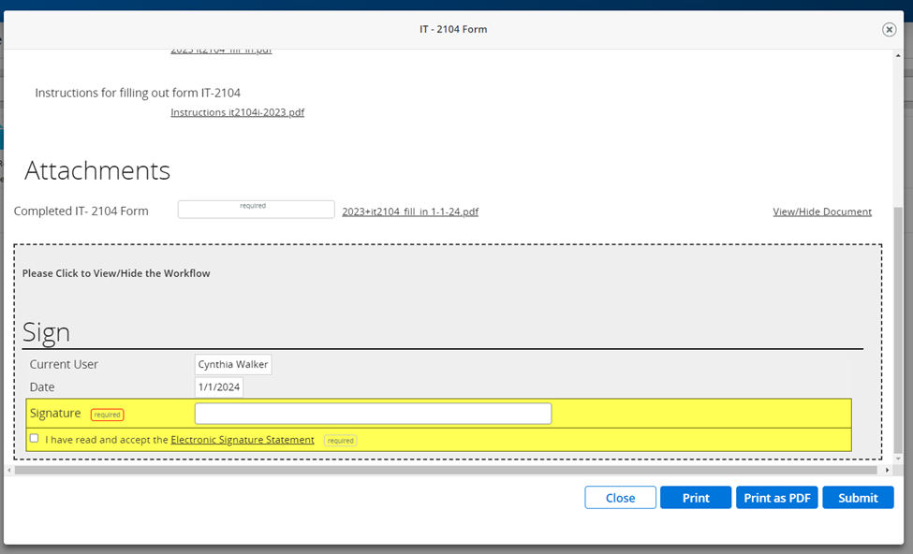
- W-4 Form - When adding or updating this form, click on the form, Add for Myself, and click Add as an E-Form. After updating your information on the E-Form, sign (type) your name and date, click the Save button.
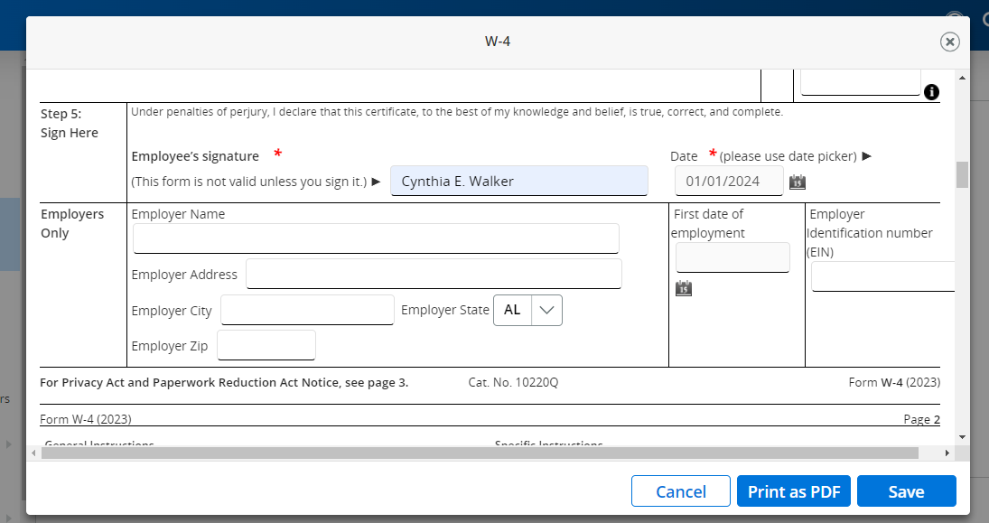
After you click Save, you will be sent an email informing you that “a document in Records requires your signature”. Click on the link in the email to bring you back to the document in Employee Records.
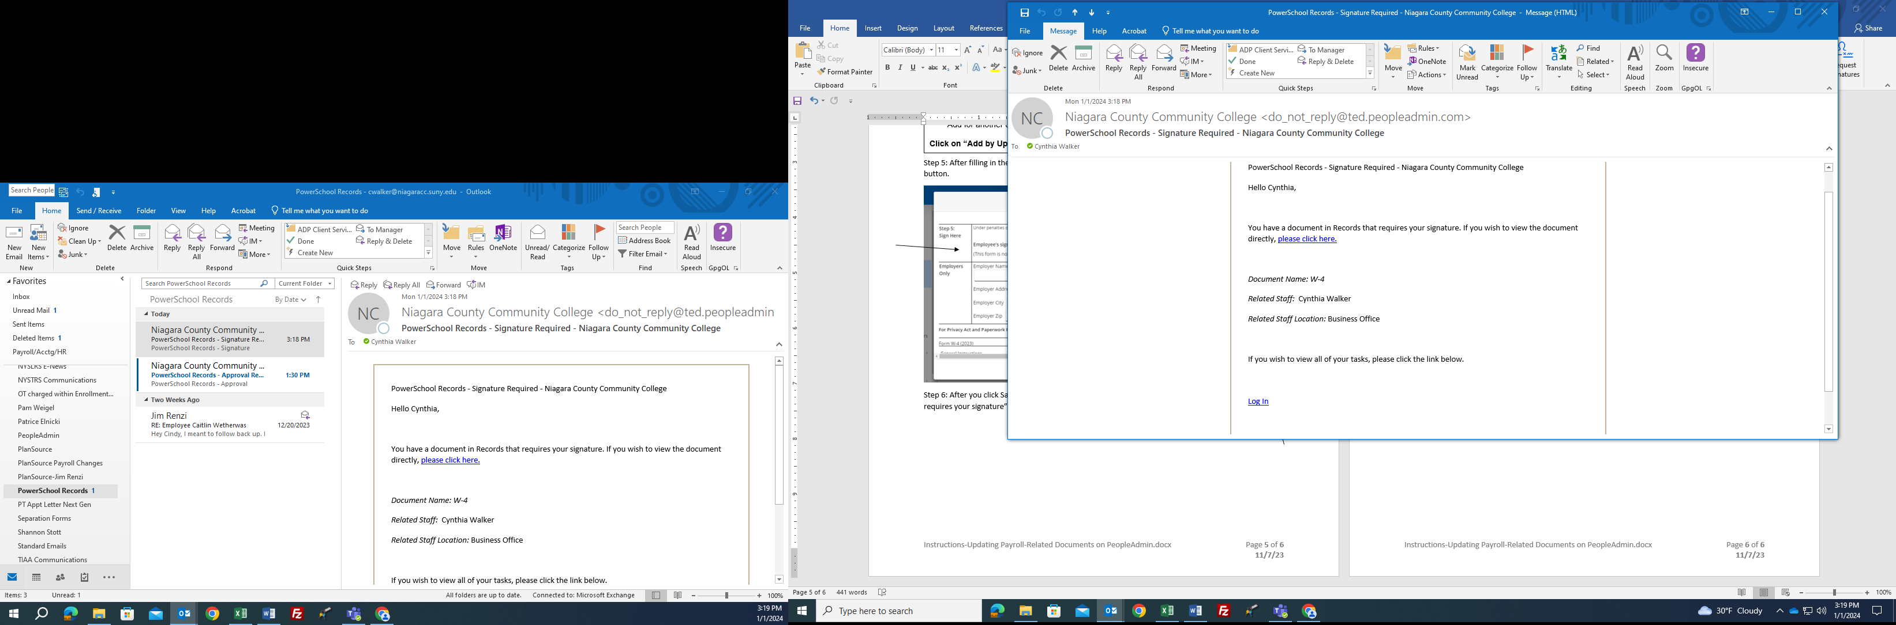
You will be directed to the Signature page of the document. You will want to type in your Signature and check the electronic Signature Statement box. Then click Submit to submit the form. Once submitted, the form routes to Human Resources.
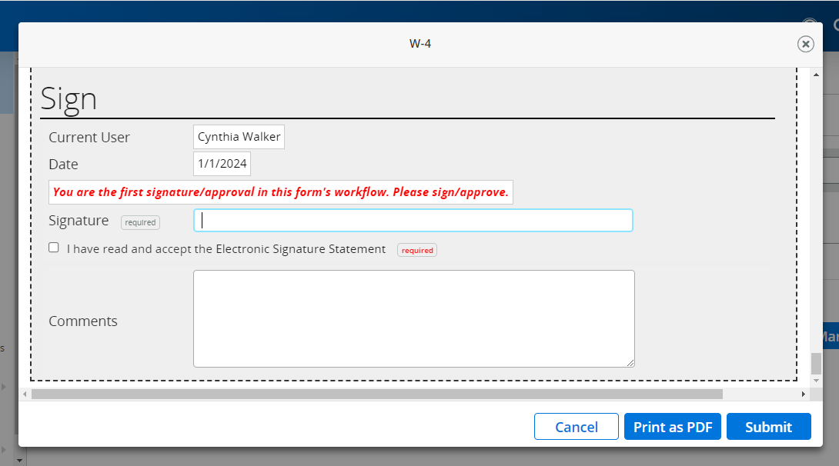

If you have any questions, please call the Payroll Office at 716-614-6442.

